**Chapter 5 Task**

**-HR schema:**

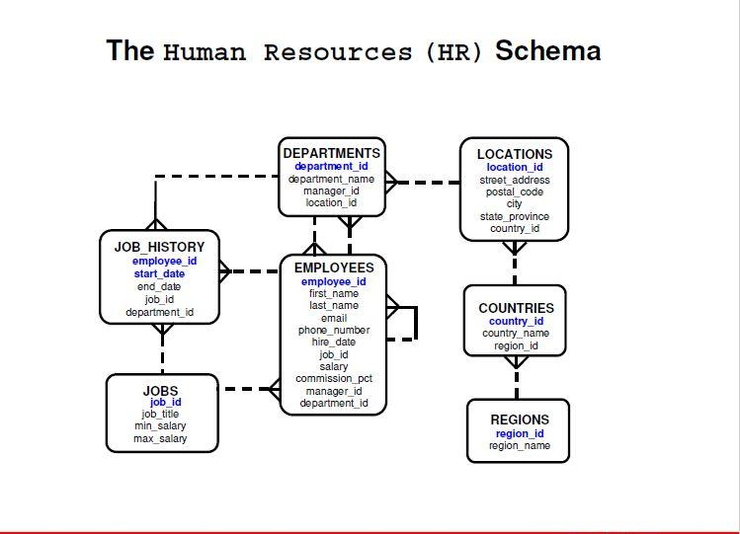

**1.Display  
 the difference between   
the highest   
and lowest salaries  
 in each department   
and rename it "Result".**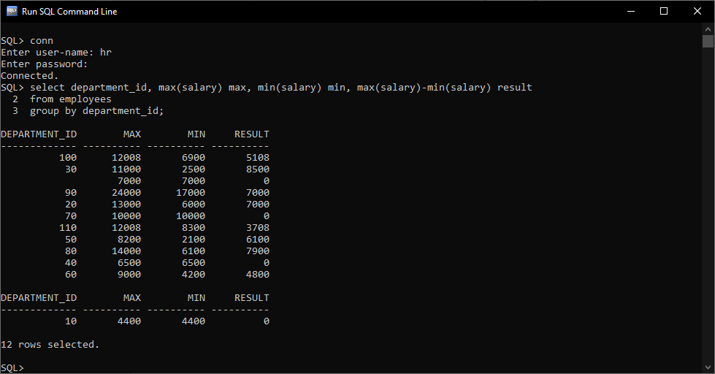



**2**

**.Display  
 the minimum salary  
 for each job << in each department.  
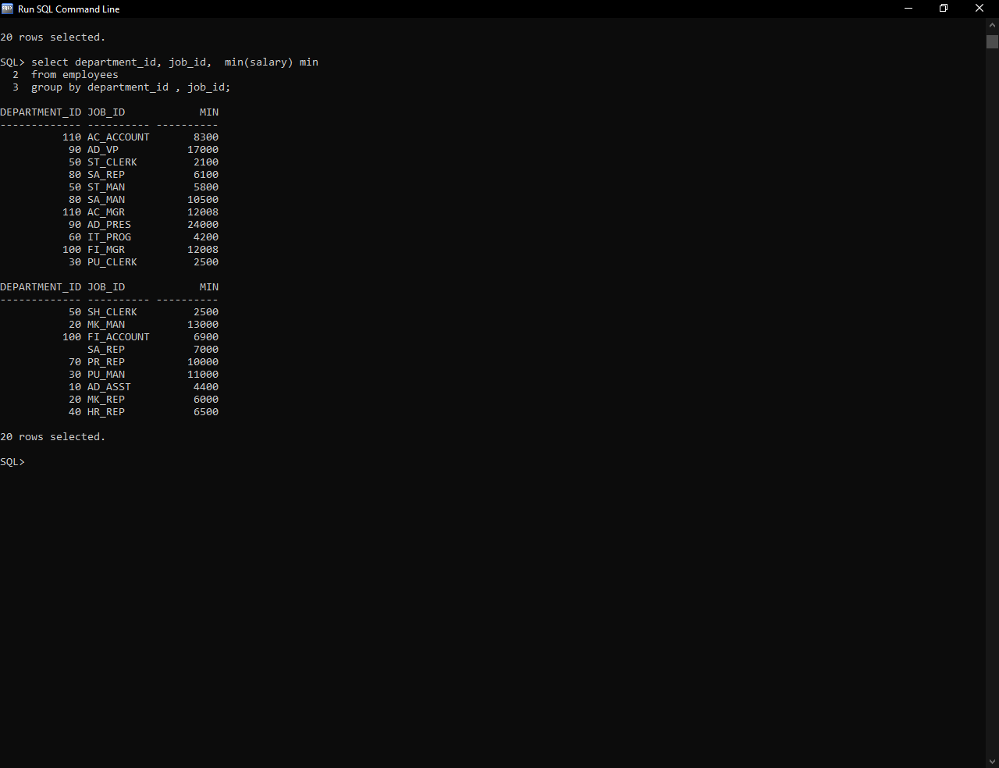**



**3.Display   
the departments  
 which their summation of salaries between 15000 and 20000  
 and display the result in descending order.  
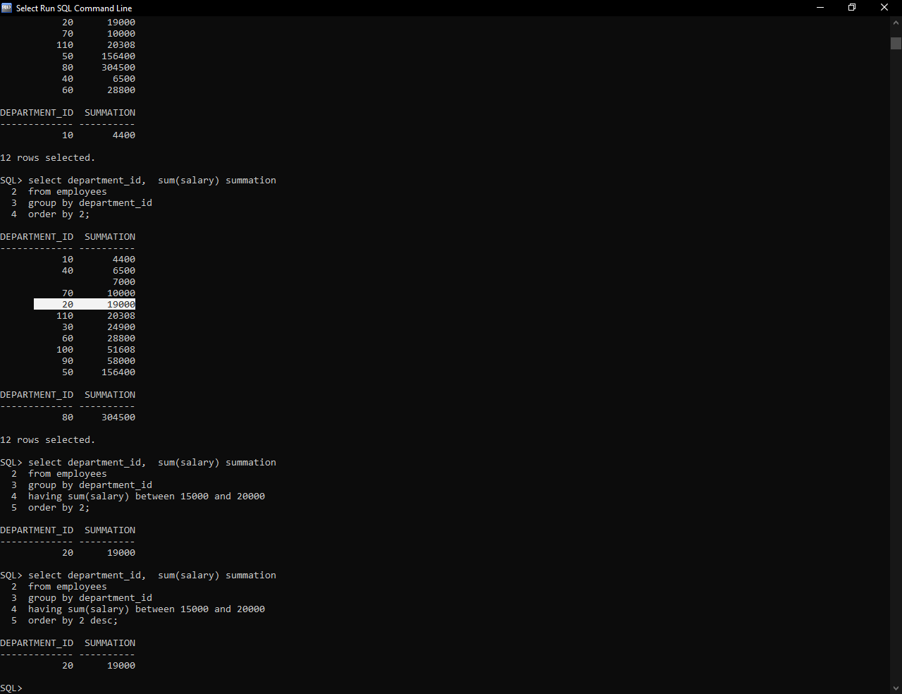**



**4.Display  
 the no.of employees  
 in the department   
that you will enter its number at run-time.  
فقط بيعرض عدد الأشخاص في القسم اللي أنا هدخل رقمه**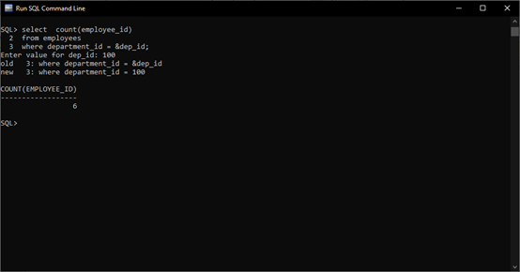

**Not the answer  
بتعرض كل الأقسام وقدامها أعداد الموظفين فيها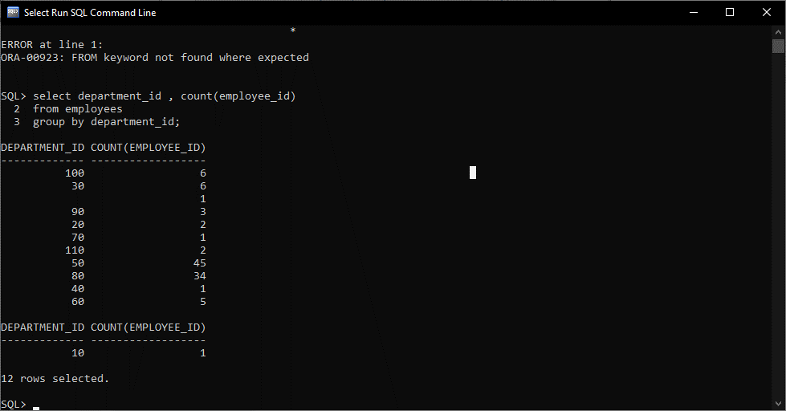 بيعرض رقم القسم وعدد الناس فيه**

**بس بشرط إني أنا اللي بدخل رقم القسم**

**وكمان بيرتب العرض حسب رقم القسم**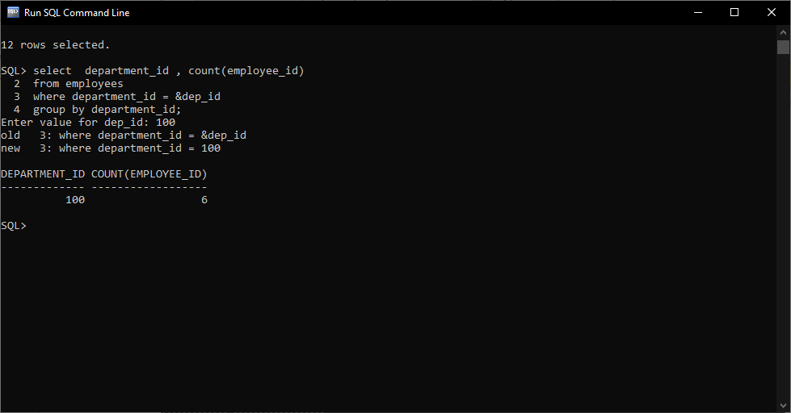



**5.Display   
the summation of salaries   
for all employees   
whose their first name not start with 'S' letter.  
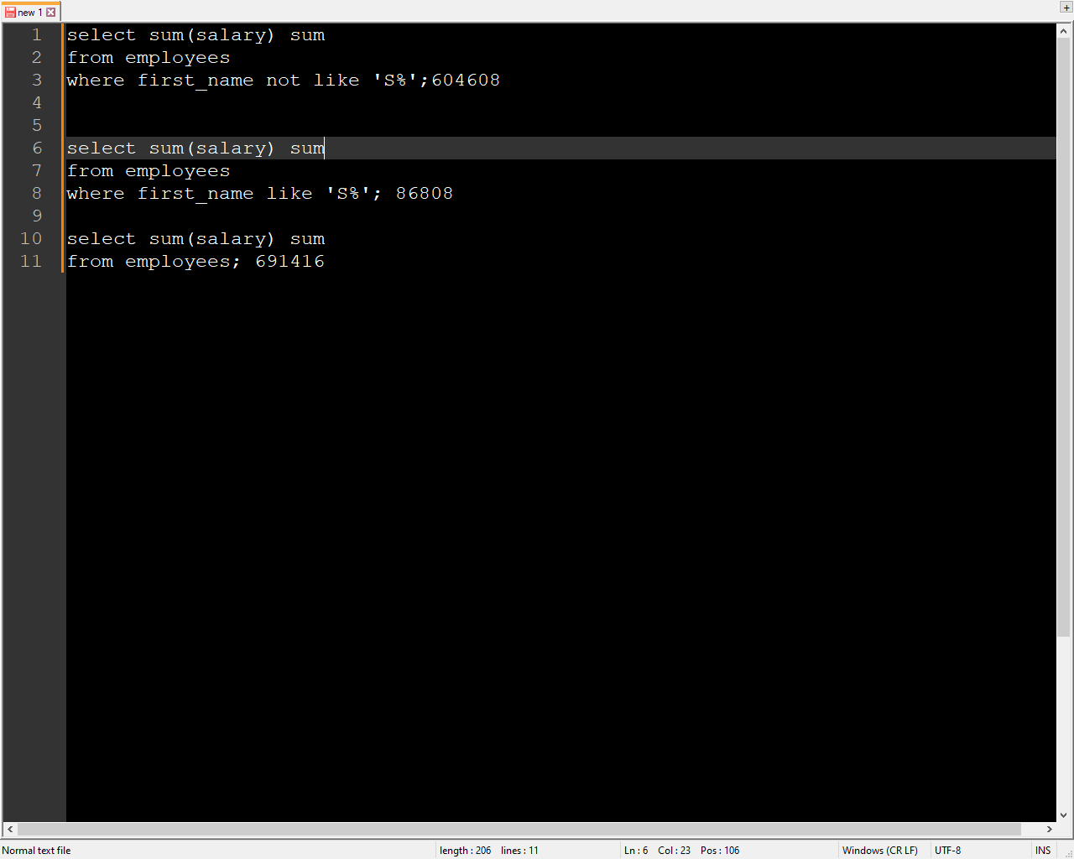**



**6.Display   
the average of commissions for employees  
 whose last names end with r   
and divide these employees into groups based on the value of salary   
and show only groups with commission average is greater than .125 ,  
 display the averages in descending order  
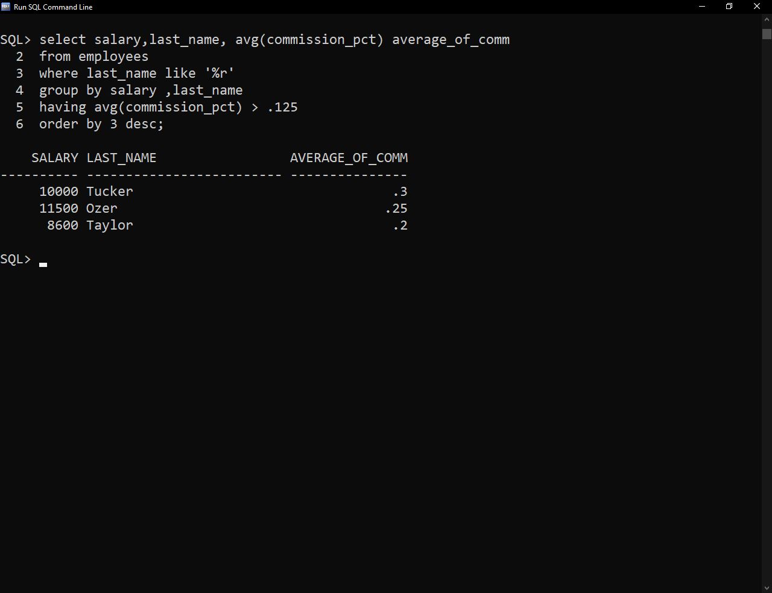**

**.**

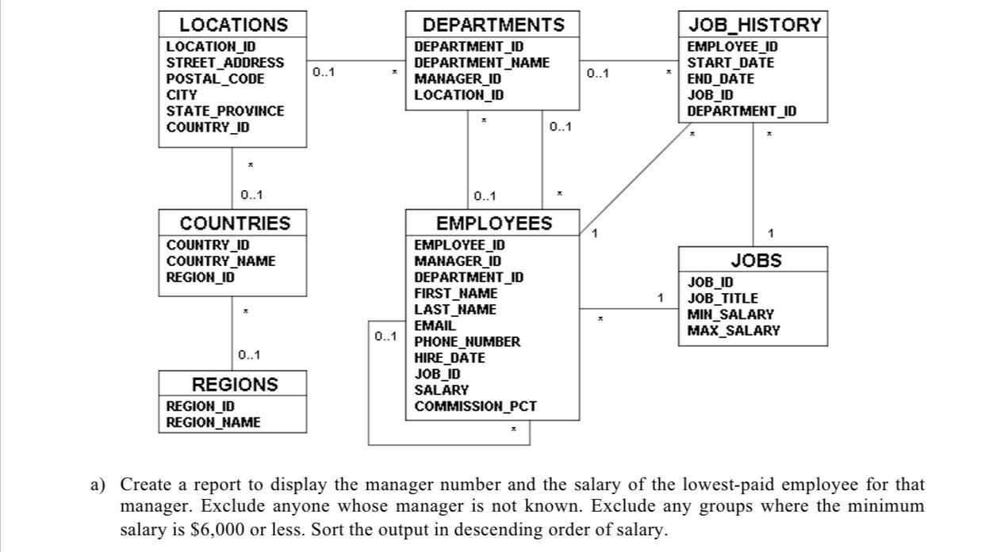

display  
 the manager number  
 and the salary of the lowest-paid employee for that manager.  
 Exclude anyone whose manager in not known.  
 Exclude any groups where the min salary is 6000 or less.   
Sort desc by salary  
